LAMPIRAN 4

PRELIMINARY DRAWING/PICTURE

ELECTRICAL DISCHARGE MACHINING & ACC

1. Main Unit (EDM)

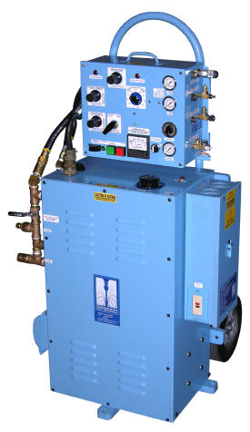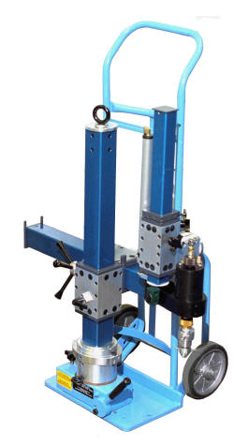

1. ACC
   1. Hydraulic Cylinder cap. 100 T

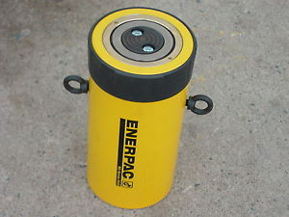

* 1. Hydraulic Cylinder cap. 150 T

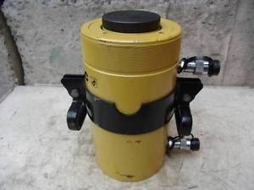

* 1. Electric Pump, ZE Class

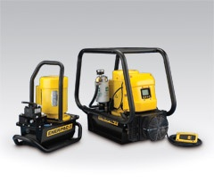

* 1. Double Acting Hydraulic Torque Wrench

